To order more items by James Holland
Contact Pentecostal Publishing House:
Telephone: 314.837.7304 ext.7
Website: www.pentecostalpublishing.com
Email: customerservice@pentecostalpublishing.com

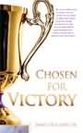 | Chosen for Victory | James Holland | 21578  We are not called to try to produce our own victory. We are called to enforce the victory Christ has already provided us. This book provides biblical understanding for you to live the life that we have been chosen for. 'Pastor James Holland shares some tremendous principles concerning victory in the life of a Christian. This is an important lesson for every believer!' -Mark Fogarty, Georgia District Secretary  Regular Price: $11.99 [PAPERBACK]
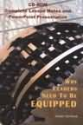 | Why Leaders Need To Be Equipped CD Rom | James Holland, Sr. | 16565  Pastor Holland offers lessons on leadership. This powerful teaching tool consists of PowerPoint presentations and teaching notes to help the pastor or church leader convey the message to lay leaders or for simple self-study. Since leadership is the foundational principle to all growth in Christian living, the leader must be prepared for the task. This lesson covers important steps in the preparation of an effective leader  Regular Price: $11.95 [CDROM]
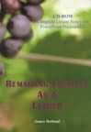 | Remaining Fruitful As Leaders CD Rom | James Holland, Sr. | 16564  Pastor Holland offers lessons on leadership. This powerful teaching tool consists of PowerPoint presentations and teaching notes to help the pastor or church leader convey the message to lay leaders or for simple self-study. Many leaders are more interested in titles than the fruit. Just because you are a leader doesn't excuse you from continuing to be fruitful in God's work.  Regular Price: $11.95 [CDROM]
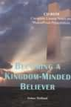 | Becoming A Kingdom Minded Believer CD Ro | James Holland, Sr. | 16563  Pastor Holland offers lessons on leadership. This powerful teaching tool consists of PowerPoint presentations and teaching notes to help the pastor or church leader convey the message to lay leaders or for simple self-study. This lesson gives us steps to change from self-centeredness to Christ-centeredness and becoming Kingdom-centered!  Regular Price: $11.95 [CDROM]
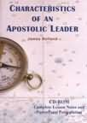 | Characteristics of An Apostolic Leader C | James Holland, Sr. | 16562  Pastor Holland offers lessons on leadership. This powerful teaching tool consists of PowerPoint presentations and teaching notes to help the pastor or church leader convey the message to lay leaders or for simple self-study. The leadership we need today is apostolic leadership. Apostolic means embodying New Testament Christianity as they did in the Book of Acts. We do not need more glorified managers; we need Spirit anointed leaders. This lesson will help to train them.  Regular Price: $11.95 [CDROM]
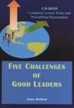 | Five Challenges of Good Leaders CD Rom | James Holland, Sr. | 16561  Pastor Holland offers lessons on leadership. This powerful teaching tool consists of PowerPoint presentations and teaching notes to help the pastor or church leader convey the message to lay leaders or for simple self-study. This lesson points out the importance of stability and keeping our focus as we do the will of God. Every leader needs to know how to face these challenges and yet be victorious.  Regular Price: $11.95 [CDROM]
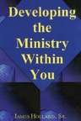 | Developing the Ministry Within You | James Holland, Sr. | 17747  Whether you are at entry-level leadership or involved at the very top of the leadership level, this book gives straightforward principles that will build strong, productive, unshakeable leadership skills.  Regular Price: $11.95 [PAPERBACK]
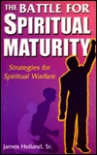 | Battle for Spiritual Maturity | James Holland, Sr. | 12665  Here are strategies for spiritual warfare. A must read for serious Christians. Venture out of your comfort zone, let God loose in your life; make that rough climb to spiritual maturity!  Regular Price: $6.95 [PAPERBACK]
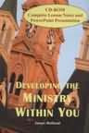 | Developing the Ministry Within You Cd | James Holland, Sr. | 13406  Rev. Holland gives you a CD-ROM providing biblical principles to develop strong leadership. It contains PowerPoint so that you can teach these four lessons to your leaders. Also included are printable lesson outlines for the teachers and question and answer handouts for the student. You will be encouraged with these four subjects: Developing Ministry, Effective Ministry, Attitudes and Pitfalls, and Becoming Fruitful. Also available are four cassettes on these subjects.  Regular Price: $11.95 [CDROM]
 | Choose To Be Free | James Holland, Sr. | 13225  How do we choose to be free? Can we really be free from emotional and spiritual bondage? Can one really have the mind of Christ? Can we be free from an unforgiving attitude? Free from bitterness, from prejudices from fear, from wrong preconceived ideas? With many scriptures, James Holland leads you on the path to freedom through Christ. The choice is yours! This book is excellent for small group studies.  Regular Price: $8.95 [PAPERBACK]

