Know the Truth Ministries
www.knowthetruthministry.org

The Way More Perfectly Bible Study (English

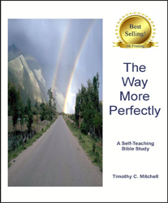

View Full- | Price
Size Price: $4.99
Image Quantity
1 - 9 | $4.99
10 - 24 | $4.65
25 - 49 | $4.35
50 - 119 | $4.00
120 - 200 | $3.75

A new, quick, and exciting Bible Study targeted toward those who are already ®saved Christians® or someone needing salvation. Designed with a running commentary that explains each scripture, one can easily teach this Bible Study with the confidence of a learned instructor. With its easy self-teaching format, you can mail this to a friend or leave it with a prospect if you

