To order more items by Gary Erickson
Contact Pentecostal Publishing House:
Telephone: 314.837.7304 ext.7
Website: www.pentecostalpublishing.com
Email: customerservice@pentecostalpublishing.com

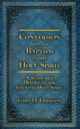 | Conversion & the Baptism of the Holy Spi | Gary Erickson | 22457  This project is written as a partial fulfillment for studies at Urshan Graduate School of Theology. This thesis will attempt to prove that the outpouring of the Holy Spirit on the Day of Pentecost, recorded in the Book of Acts chapter 2, was not only a miraculous phenomenon of dispensational precedence for the first-century believers but also a paradigm for conversions into the Christian church from the apostolic era until the Second Coming.  Regular Price: $19.95 [HARDBACK]
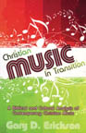 | Christian Music in Transition | Gary Erickson | 22367  The musical saturation of our society, bizarre extremes in popular music, and the commercialization of youth-directed music in this generation are a historical phenomenon. The void of moral leadership in some homes has given place for music to mentor the youth of America, providing the most decadent, rebellious, and crude sermons. Christian music is challenged as never before wtih compromise. Guidelines are needed to avoid the inevitable pitfalls.  Regular Price: $9.95 [PAPERBACK]
 | Our Just Right World | Gary Erickson & David Reynolds | 22779  This is a colorful children's book about the wonders of Creation. Goldilocks and Baby Bear discover the amazing 'just right' world God made for us. The book is excellent for reading aloud to children or letting them read it alone.  Regular Price: $9.95 [PAPERBACK]
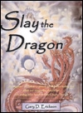 | SS Chr Slay The Dragon And Save The Chil | Gary Erickson | 11206  There is an unprecedented attack against children in today's culture. This book relates the cultural attack and how to defend our children against it.  Regular Price: $14.95 [BOOK]
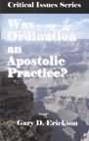 | Was Ordination An Apostolic Practice | Gary Erickson | 17379  This booklet was originally written as a term paper for Urshan Graduate School of Theology. Erickson has presented an issue that many have questioned but few have approached. He sheds spiritual and scholarly light on this critical issue.  Regular Price: $5.00 [PAPERBACK]
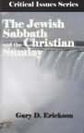 | Jewish Sabbath And the Christian Sunday | Gary Erickson | 17376  This booklet was originally written as a term paper for Urshan Graduate School of Theology. Erickson has presented an issue that many have questioned but few have approached. He sheds spiritual and scholarly light on this critical issue.  Regular Price: $5.00 [PAPERBACK]
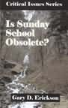 | Is Sunday School Obsolete? | Gary Erickson | 17375  This booklet was originally written as a term paper for Urshan Graduate School of Theology. Erickson has presented an issue that many have questioned but few have approached. He sheds spiritual and scholarly light on this critical issue.  Regular Price: $5.00 [PAPERBACK]
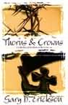 | SS Teach Thorns and Crowns | Gary Erickson | 17142  NONE  Regular Price: $9.95 []
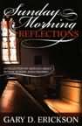 | SS Chr Sunday Morning Reflections | | 17139  You will find insight, inspiration, and information from these pages, and it is the hope of the writer that it will inspire a new vision for Sunday school and children's ministry.  Regular Price: $9.95 [PAPERBACK]
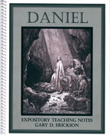 | Daniel: Expository Teaching Notes | Gary Erickson | 4195  This is a verse-by-verse composition of study notes through the Book of Daniel (a commentary in outline form). It is composed of twenty-five outlined lessons. Great for teaching and studying.  Regular Price: $12.95 [SPIRALBND]
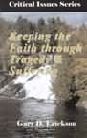 | Keeping the Faith Through Tragedy And Su | Gary Erickson | 17377  This booklet was originally written as a term paper for Urshan Graduate School of Theology. Erickson has presented an issue that many have questioned but few have approached. He sheds spiritual and scholarly light on this critical issue.  Regular Price: $5.00 [PAPERBACK]
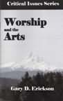 | Worship And the Arts | Gary Erickson | 17378  This booklet was originally written as a term paper for Urshan Graduate School of Theology. Erickson has presented an issue that many have questioned but few have approached. He sheds spiritual and scholarly light on this critical issue.  Regular Price: $5.00 [PAPERBACK]
 | SS Care Hope Book | Gary Erickson | 13827  This book along, with the H.O.P.E Door Hanger, is a wonderful way to reach your community. Chapter One explains the plan of salvation and 21 chapters deal with various contemporary issues in life (raising children, overcoming vices, handling money, etc). Giving Biblical answers to difficult questions. Door hangers sold separately.  Regular Price: $8.00 [PAPERBACK]
 | SS Teach 101 Tips for Teachers | | 16925  Just as the title says, this book contains 101 tips to help teacher hone their skills. It covers a wide variety of topics in short concise chapters. It will motivate and educate those who teach.  Regular Price: $9.95 [PAPERBACK]
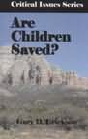 | Are Children Saved ? | Gary Erickson | 17374  This booklet was originally written as a term paper for Urshan Graduate School of Theology. Erickson has presented an issue that many have questioned but few have approached. He sheds spiritual and scholarly light on this critical issue.  Regular Price: $5.00 [PAPERBACK]
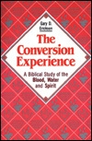 | Conversion Experience, The RR | Gary Erickson | 8077  The most important issue facing mankind is how to be saved. This book addresses the subject of entrance into the Christian church frequently referred to as conversion.  Regular Price: $11.99 [PAPERBACK]
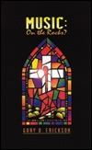 | Music On the Rocks | Gary Erickson | 8455  Here is a book that provides practical and biblical assistance for those concerned about Christian music in our modern world.  Regular Price: $11.95 [SPIRALBND]
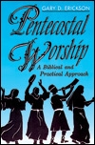 | Pentecostal Worship RR | Gary Erickson | 7016  This book on worship for the worship leader, worshiper, non-worshiper, musician, and pastor addresses the subject from a classic Pentecostal background.  Regular Price: $12.99 [PAPERBACK]
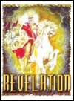 | Revelation | Gary Erickson | 5630  This is a verse-by-verse composition of study notes through the Book of Revelation (a commentary in outline form). It is composed of an introduction, written in paragraph form, and thirty-six outlined lessons. Great for teaching and studying.  Regular Price: $19.95 [SPIRALBND]
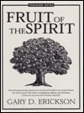 | Fruit of the Spirit | Gary Erickson | 5481  This book systematically examines the nine fruit of the Spirit in ten outlined lessons and twenty visuals. The subject is enlightening, edifying, and challenging.  Regular Price: $12.00 [SPIRALBND]

