To order more items by Carole Keller
Contact Pentecostal Publishing House:
Telephone: 314.837.7304 ext.7
Website: www.pentecostalpublishing.com
Email: customerservice@pentecostalpublishing.com

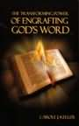 | Transforming Power of Engrafting God's W | Carole Keller | 19135  Keller expertly shares the power of Scripture to aid people in overcoming the various pains in their lives. By making a point, buttressing it with Scripture, and then applying that point to real life, the author successfully shares "Engrafting the Word of God," "Meditating for Success," "Finding the Knowledge of God," and "Relationship with the King." Accessible and inspiring for new saints and veteran believers.  Regular Price: $10.00 [PAPERBACK]
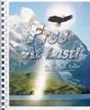 | Free At Last | Carole Keller | 19488  The author offers 10 steps that share principles of righteousness with the downhearted and depressed so that they might welcome the light of Christ into their lives, be they Christian or otherwise. The 10 steps (including: Confessing faults, Transforming the mind, Loving yourself, Redemption and deliverance) apply to adults and children. "Free at Last should hold a special place in every pastor's library. It is a necessity for the desk of every Christian counselor. I have never read such a complete guide for healing of the afflictions of our times." -Pastor Anthony Tamel, Parkway Apostolic Church, Wisconsin  Regular Price: $21.00 [SPIRALBND]
  Other Books By Carole J Keller can be ordered at
  www.freeatlastministries.us
  * Price does not include postage
  AT LAST
  FREE AT LAST is a blue print for overcoming negativity and addictive behaviors that keep recycling in one scenario after the other. It is a must read for anyone who has been a victim of drug abuse, marital abuse, child abuse, or anyone dealing with adult child issues and a less than fulfilling life based on past hurts, pains and unforgiveness. Whether you have been a victim, victimizer, or are seeking a healing in your life, this book has the answers. Based on Biblical teachings and learning to use the Word to the full power of it, this book has all the tools to help you develop into the potential God has for you. The most liberating principle for freedom is simply telling the truth. Free at Last stresses the affirming power of speaking truthfully and confronting giants of the past as measured against the destructive power of repressing fears, anger, and injustices. There is not a more powerful principle for restoring life than to bring darkness into the light. A corresponding 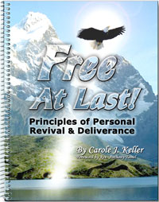component introduced in this course is engrafting God's Word to renew the mind and conquer oppressive belief systems.
  Price: $22.00*
  To place an order, click here
  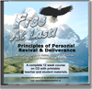FREE AT LAST TEACHER'S MANUAL/CURRICULUM CD
  The curriculum includes outlines for 12 lessons, various exhibits, and teaching notes, corresponding to the text, Free at Last. Students are encouraged to purchase a copy of the textbook.
  Click Here for Table of Contents
  Click Here for Lesson Topics
  Price: $30.00*
  To place an order, click here
  The Transforming Power of Engrafting God’s Word
  Acquiring the discipline to speak positively can alter our destiny as the words we speak into existence establish our boundaries in life. In The Transforming Power of Engrafting God's Word, the author establishes the principles for engrafting God's Word. 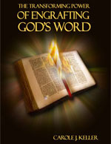Believers who put into practice the principles set forth in this book will experience power to overcome any fault, wisdom to make wise choices, restored relationships, and intimacy with God, which leads to freedom. Engrafting will restore a love for truth as it gives birth to passion, convictions and boldness to speak them forth. Once engrafted, the Word will never come back void, but in ever temptation will guide us to do what is right. Therefore, the power of God's spoken Word will lead believers into a new dimension in this hour in which they will be able to discern truth from error, holiness from worldliness, because they have the mind of God.
  ENDORSEMENTS & TESTIMONIALS:
  The Transforming Power of Engrafting God's Word is a well written, easily understood challenge to not just memorize the Word of God, but to make it part of one's life. The easy reading style of the book does not minimize the profound truths that are being disseminated in such an articulate way. Embracing the truths of this book can transform any person into a power house for God. It will soon become part of the required curriculum at the National Bible School in Nigeria and hopefully, someday around the world. It should be "must reading" for all new converts, as well as seasoned saints.
  - Gerald C. McLean
  UPCI Missionary, Nigeria, West Africa
  "When I had cancer, I realized that the best way for me to fight the cancer and the emotional trauma associated with it was to put positive and Godly thoughts in my mind every day. I relied heavily on three main books that I read on a daily basis throughout the duration of my cancer treatment:The Bible, and Carole Keller's books - There’s Healing in His Wings and The Transforming Power of Engrafting God’s Word . I recited every scripture out loud. There was such a powerful spirit of truth and faith emanating from the books that ministered to my spirit and upheld me during a very stressful time in my life."
  – Sharon Jadrnicek
  Price: $10.00*
  To place an order, click here
  There's Healing in His Wings
  Carole Keller describes how your damaged emotions can be healed through the biblical principle of surrender. Surrendering crosses to God on a daily basis reduces stress, avoids conflict, and restores self worth through the power of the Holy Spirit when you stop working in your own power.
  Price: $14.00*
  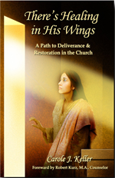To place an order, click here
  In The Law of the Spirit, the author challenges the concept that the “law” is done away with. She suggests such thinking has contributed to today’s toleration for unrighteousness and an overall departure from God’s Word - spirituality without knowing the mind of the Spirit. Rather than abolish the law, Jesus fulfilled every bit of it, in Himself, becoming the very lamb slain to take away the sins of the world. Breaking the barrier between Himself and man, God ushered in a new law, the Law of the Spirit of Life in Christ Jesus, so that His laws are no longer written on tablets of stone, but written upon our hearts. His passion is for us to know Him personally and obey Him willingly, through faith, as heirs of the promise. By surrendering things that have held us captive, we can 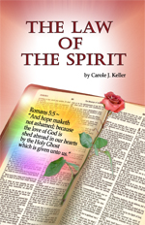find grace to be led and empowered by the Spirit, and change our world!
  Price: $11.00*
  To place an order, click here
  STAND UP AMERICA - A Grassroots Bible Study to Restore Righteousness to the Land
  Includes chapters on:
  - How the hand of God and Judeo-Christian principles established the foundation of America from the Mayflower Compact through the U.S. Constitution
  - How Christianity paved the way for self-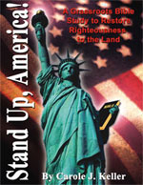government in America
  - The Covenantal relationship between the colonial forefathers and God and how the Covenantal promises passed across generations. The cultural changes we see today, the trend toward one-world government and its impact upon America's Republic
  - Apostolic Revival and restoration of the people
  - The sacred rights and responsibilities of the people
  - The liberating power of Biblical confrontation and how speaking the truth heals offenses, restores righteousness, and empowers the governed to stand up for Judeo-Christian principles in America.
  The closing chapter is on America as a "city set upon a hill," the vision for America spoken into existence by John Winthrop 375 years ago, passed down to succeeding generations of Americans and reaffirmed in the 21st Century by President Ronald Reagan. A summary is given in the concluding chapter as to a course Christians can pursue to restore America's purpose and original vision. The book, containing numerous quotations from the Founding Fathers and democratic theorists in the founding of America, can also be used as a group bible study tool.
  Price: $22.00*

