To order more items by Lori Wagner
Contact Pentecostal Publishing House:
Telephone: 314.837.7304 ext.7
Website: www.pentecostalpublishing.com
Email: customerservice@pentecostalpublishing.com

A Patchwork of Freedom
Price:$14.95
Availability: In Stock
Select Quantity:
Author: Lori Wagner
SKU:23295
ISBN: 9780979862779

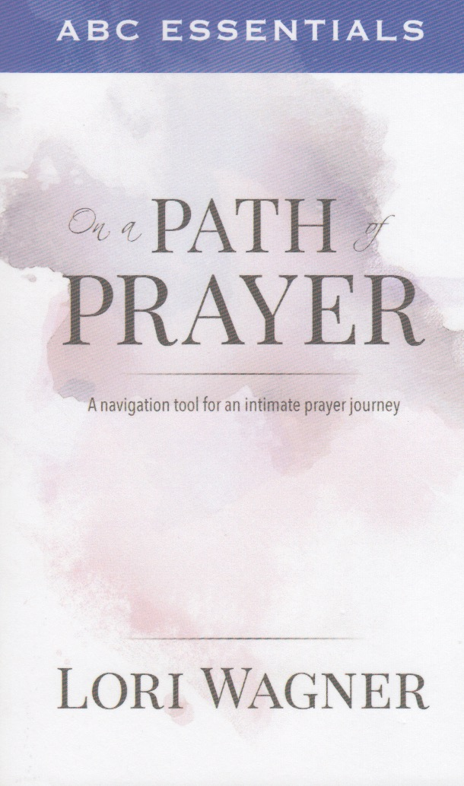

ABC Essentials on a Path of Prayer
Price:$11.95
Author: Lori Wagner
SKU:29885
ISBN: 9780989737388

Arise: Walk in the Sunrise
Price:$12.99
SubTitle: A 10-Week Devotional Prayer Journal
Author: Lori Wagner
SKU:27173

Buttercup - Book 2 of The Briar Hollow Series
Price:$14.99
SubTitle: Book 2 of The Briar Hollow Series
Author: Lori Wagner
SKU:25366
ISBN: 9780989737302

