To order more items by Ralph V. Reynolds
Contact Pentecostal Publishing House:
Telephone: 314.837.7304 ext.7
Website: www.pentecostalpublishing.com
Email: customerservice@pentecostalpublishing.com

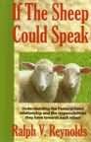 | If the Sheep Could Speak | Ralph Reynolds | 20987  Product Description  If you are a pastor, minister, Christian worker, or a saint, this book will speak to you! It teaches, directs, opens doors of new thought, and confirms the true way of pastoral guidance.  (Ordination License Minister Package)  Regular Price: $10.00 []
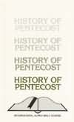 | HISTORY OF PENTECOST - Alpha Bible Cours | Ralph Reynolds | 2813  A part of the English International Alpha Bible Course, History of Pentecost is a study of the early Pentecostal revival in North America. Not available for sale in North America.  Regular Price: $4.00 [BOOK]
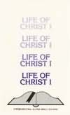 | FM Life of Christ I - Alpha Bible Course | Ralph Reynolds | 2783  A part of the English International Alpha Bible Course, Life of Christ I contains twelve lessons concerning the four Gospels; geography of Palestine; the four hundred silent years; the times of Jesus; John the Baptist; the birth and childhood, the baptism, and temptation of Jesus, the twelve disciples, and the three years of ministry. Not available for sale in North America.  Regular Price: $4.00 [BOOK]
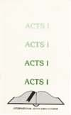 | FM Acts I - Alpha Bible Course - Not fo | Ralph Reynolds | 3123  A part of the English International Alpha Bible Course, Acts I is a study of the first eleven chapters of the Book of Acts. Not available for sale in North America.  Regular Price: $4.00 [BOOK]
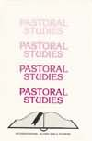 | FM Pastoral Studies - Alpha Bible Course | Ralph Reynolds | 2794  A part of the International Alpha Bible Course, Pastoral Studies contains twelve lessons concerning the role and ministry of pastors. Not available for sale in North America.  Regular Price: $4.00 [BOOK]
 | OLD TESTAMENT HISTORY II - Alpha Bible C | Ralph Reynolds | 2815  A part of the English International Alpha Bible Course, Old Testament History II is a study of Jewish history from the time of King Solomon through Nehemiah. Not available for sale in North America.  Regular Price: $4.00 [BOOK]
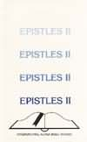 | FM Epistles II - Alpha Bible Course - No | Ralph Reynolds | 2737  A part of the English International Alpha Bible Course, Epistles II is a study of Paul's letters to the Galatians, Ephesians, Philippians, Colossians, and Thessalonians. Not available for sale in North America.  Regular Price: $4.00 [BOOK]
FM Epistles I - Alpha Bible Course - Not | Ralph Reynolds | 2736
A part of the English International Alpha Bible Course, Epistles I is a study of Paul's letter to the saints at Rome and his two letters to the Corinthians. Not available for sale in North America.
Regular Price: $4.00 [BOOK]
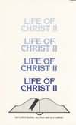 | FM Life of Christ II - Alpha Bible Cours | Ralph Reynolds | 2785  A part of the English International Alpha Bible Course, Life of Christ II contains twelve lessons concerning the ministry of miracles, miracles of supply, miracles of deliverance, miracles of healing, miracles of judgment, and Jesus, the Creator. Not available for sale in North America.  Regular Price: $4.00 [BOOK]
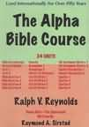 | Alpha Bible Course, The CD Rom | Ralph Reynolds | 17425  This Bible course, which has been used internationally for over fifty years, has now been put on CD-ROM in PDF format. The 24 lesson units contain the notes as well as study questions following each unit. The following topics are covered: Bible Introduction, Pastoral Studies, Acts, Bible Doctrine, Genesis, Evangelism, History of Pentecost, Life of Christ, Old Testament History, Daniel & Revelation, and the Epistles. A bonus unit covering the Tabernacle written by Raymond Sirstad is also included.  Regular Price: $59.99 [CDROM]

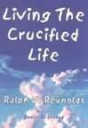 | Living the Crucified Life Cd | Ralph Reynolds | 17410  This audio book will challenge you to live a life above the ordinary. Reynolds challenges listeners to live beyond a life of defeat. As you sit at the foot of the cross, may you truly experience the abundant life. (3 CDs)  Regular Price: $15.00 [CD]
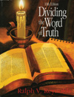 | Dividing the Word of Truth Rr | Ralph Reynolds | 9842  An outline study to help give foundation to students in their knowledge of the Word of God.  Regular Price: $19.95 [PAPERBACK]
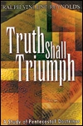 | Truth Shall Triumph | Ralph Reynolds | 8009  A study of 12 Pentecostal doctrines presented in a manner that will assist readers to impart these truths to others.  Regular Price: $11.99 [PAPERBACK]
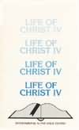 | FM Life of Christ Iv - Alpha Bible Cours | Ralph Reynolds | 2789  A part of the English International Alpha Bible Course, Life of Christ IV contains twelve lessons concerning the events from the triumphant entry to the ascension. Not available for sale in North America.  Regular Price: $4.00 [BOOK]
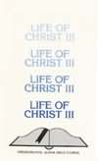 | FM Life of Christ Iii - Alpha Bible Cour | Ralph Reynolds | 2787  A part of the English International Alpha Bible Course, Life of Christ III contains twelve lessons concerning the Sermon on the Mount, parables, salvation, the church and her future, the kingdom of God, the Law, material and spiritual values, the final destiny of man, the deity of Christ, the promise of the Return. Not available for sale in North America.  Regular Price: $4.00 [BOOK]
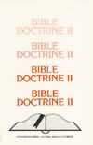 | FM Bible Doctrine II - Alpha Bible Cours | Ralph Reynolds | 3130  A part of the English International Alpha Bible Course, Bible Doctrine II contains twelve lesson dealing with angels, the devil, sin, man, the love of God, the Atonement, the resurrection of Jesus, and the Double Cure.  Regular Price: $4.00 [BOOK]
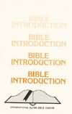 | FM Nfs Us Bible Intro - Abc | Ralph Reynolds | 2792  A part of the English International Alpha Bible Course, Bible Introduction is a study of the development of the English Bible.  Regular Price: $4.00 [BOOK]
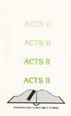 | FM Acts II - Alpha Bible Course - Not f | Ralph Reynolds | 3124  A part of the English International Alpha Bible Course, Acts II is a study of chapters 12-28 of the Book of Acts. Not available for sale in North America.  Regular Price: $4.00 [BOOK]
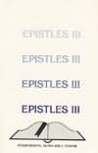 | FM Epistles Iii - Alpha Bible Course - N | Ralph Reynolds | 2739  A part of the English International Alpha Bible Course, Epistles III is a study of Paul's letters to Timothy, Titus, and Philemon and the letter to the Hebrews. Not available for sale in North America.  Regular Price: $4.00 [BOOK]
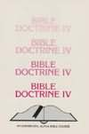 | FM Bible Doctrine Iv - Alpha Bible Cours | Ralph Reynolds | 3132  A part of the English International Alpha Bible Course, Bible Doctrine IV contains twelve lessons dealing with the church, the kingdom of God, spiritual sacrifices, the church, death, resurrection, judgments and rewards, heaven, the destiny of the wicked, and eternity. Not available for sale in North America.  Regular Price: $4.00 [BOOK]

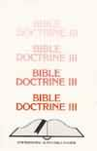 | FM Bible Doctrine Iii - Alpha Bible Cour | Ralph Reynolds | 3131  A part of the English International Alpha Bible Course, Bible Doctrine III contains twelve lessons dealing with the titles of Jesus, the name of Jesus, salvation, repentance, faith, justication, regeneration, sanctification, holiness, perfection, eternal security, and healing received. Not available for sale in North America.  Regular Price: $4.00 [BOOK]
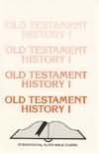 | FM Old Testament History I - Alpha Bible | Ralph Reynolds | 2793  A part of the English International Alpha Bible Course, Old Testament History I is a study of Jewish history from the time of the wilderness wanderings through the life of King David. Not available for sale in North America.  Regular Price: $4.00 [BOOK]
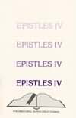 | FM Epistles Iv - Alpha Bible Course - No | Ralph Reynolds | 2741  A part of the English International Alpha Bible Course, Epistles IV is a study of Pastoral Epistles: James, I Peter, II Peter, I John, II John, III John, and Jude. Not available for sale in North America.  Regular Price: $4.00 [BOOK]
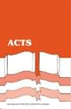 | ACTS - Overseas Ministries Training Cour | Darline Kantola & Ralph Reynol | 4200  A part of the Overseas Ministries Training Course; a study of the Book of Acts of the Apostles  Regular Price: $4.00 [PAPERBACK]
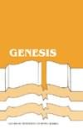 | FM Overseas Ministries Training Course - | Darline Kantola & Ralph Reynol | 4230  A part of the Overseas Ministries Training Course;a study of the Book of Genesis  Regular Price: $4.00 [BKLT]
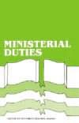 | FM Overseas Ministries Training Course M | Ralph Reynolds & W.H. Cole | 4243  A part of the Overseas Ministries Training Course; a look at ministerial responsibilities and duties  Regular Price: $2.00 [BOOK]

