To order more books by Rufus Parker
Contact Pentecostal Publishing House:
Telephone: 314.837.7304 ext.7
Website: www.pentecostalpublishing.com
Email: customerservice@pentecostalpublishing.com

Developing the Man in the Mirror
Rufus Parker
In a powerful and fresh approach to leadership, Rufus Parker shares many of the leadership insights and lessons he learned and taught during his military career. As a former command sergeant major and senior enlisted advisor, he speaks from years of experience.

Reflection of the Man in Mirror
Rufus Parker
The reason there are few laborers is not because God is not sending, but because we are not developing, Parker declares. Drawing on twenty-eighty years of military excellence, he arms leaders by sharing ten steps to be effective (and factors that hinder effectiveness), defining discipline, and explaining stress management techniques, while exploring the deeper meanings of loyalty, and important scriptural principles. This book, a sequel to Developing the Man in the Mirror, is an important addition to every leader's library.

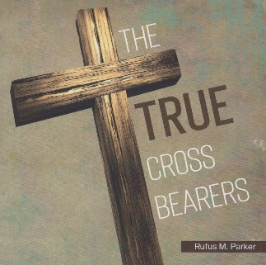
The True Cross Bearers
Rufus Parker
Exactly what did Jesus mean when He said, "And whosever does not take his cross, and come after me, cannot be my disciple?" What was the significance of the cross, and why must we teach it? Why did Jesus select the cross as one of the methods in making us His disciples? Were His words prophetic? Was He stating that we must literally die on a cross like Him, or we cannot be His disciple, or was there a deeper meaning? I find that His words always have more than a surface meaning. In this book, I focus on five areas that I believe the cross Jesus represent the cross Jesus has called us to carry. We should all ask ourselves, "What will I need to do to bear my cross daily, and how can I follow His example while doing it?

