To order more books by Fred Foster
Contact Pentecostal Publishing House:
Telephone: 314.837.7304 ext.7
Website: www.pentecostalpublishing.com
Email: customerservice@pentecostalpublishing.com

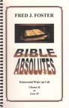 | Bible Absolutes  Pentecostal Wake-up Call  by Fred Foster  Fred Foster has written a thought-provoking book, urging Pentecostals to adhere to God’s call to holiness—both outward and inward holiness.  “Fred Foster’s ministry has for decades impacted the work of God through powerful preaching and exceptional leadership. His latest book challenges succeeding generations of the church to be a ‘called out,’ clearly defined people whose vision and task is to please the Lord Jesus and to reach this world with the gospel. This is a compelling book and would be an important addition to your library.” –Mark Christian  Media Type: Spiral Bound  Copyright: ©2005  Size: 5.75 x 8.5  Number Of Pages: 65  ISBN: 0757732143  Availability Status:  Price: $10.00
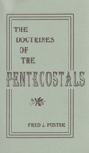 |  | Doctrines of the Pentecostals, The  by Fred Foster  From the foundational doctrines of faith and salvation, to a separated lifestyle, to the last days, this book has clear biblical teachings. It will “hit the spot,” whether you’re a new convert or have been a Pentecostal for years.  Media Type: Spiral Bound  Copyright: ©2002  Size: 5.5 x 8.5  Number Of Pages: 162  ISBN: 0757727115  Availability Status:  Price: $12.00
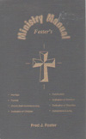 | Foster's Ministry Manual  by Fred Foster  Contains helpful information and services for ministers for weddings, funerals, church staff commissioning, dedication of children, communion, ordination of ministers, dedication of churches, and cornerstone laying.  Media Type: Spiral Bound  Copyright: ©1996  Size: 5.5 x 8  Number Of Pages: 106  ISBN: 0757708080  Availability Status:  Price: $12.00
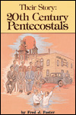 | Their Story: Twentieth Century Pentecostals  by Fred Foster  A complete and straightforward presentation of the modern Oneness Pentecostal movement. Rev. James Kilgore writes, "This book is beyond the ordinary, inasmuch as it is a book of our church history, a reference book, and certainly one to give us a challenge to be Pentecostal at any cost."  Media Type: Paperback  Copyright: ©1965  Size: 5.25 x 8  Number Of Pages: 192  ISBN: 0912315059  Availability Status:  Price: $12.99
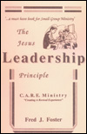 | Jesus Leadership Principle, The  C.A.R.E Ministry  by Fred Foster  This small-group ministry handbook can transform the local church into a caring, evangelistic body of believers by using the Jesus Leadership Principle.  Media Type: Spiral Bound  Copyright: ©1992  Size: 5.5 x 8.5  Number Of Pages: 115  ISBN: 0757708102  Availability Status:  Price: $12.00
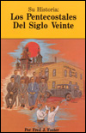 | Su Historia: Los Pentecostales del Siglo Viente (Their Story: Twentieth Century Pentecostals)  by Fred Foster  A complete and straightforward presentation of the modern Oneness Pentecostal movement. Rev. James Kilgore writes, "This book is beyond the ordinary, inasmuch as it is a book of our church history, a reference book, and certainly one to give us a challenge to be Pentecostal at any cost."  Media Type: Paperback  Copyright: ©1989  Size: 5.25 x 8  Number Of Pages: 200  ISBN: 0932581358  Availability Status:  Price: $12.99

