To order more books by J.R. Ensey, follow the link below to Amazon.
https://www.amazon.com/J.-R.-Ensey/e/B001HOPX4Q%3Fref=dbs_a_mng_rwt_scns_share
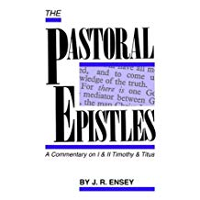

The Pastoral Epistles: A Commentary on I and II Timothy and Titus

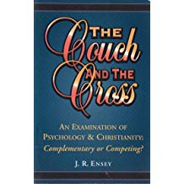
The Couch and the Cross

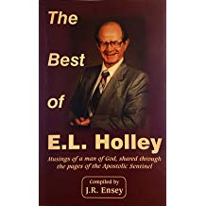
The Best of E. L. Holley: Musings of a Man of God, Shared Through the Pages of the Apostolic Sentinel

