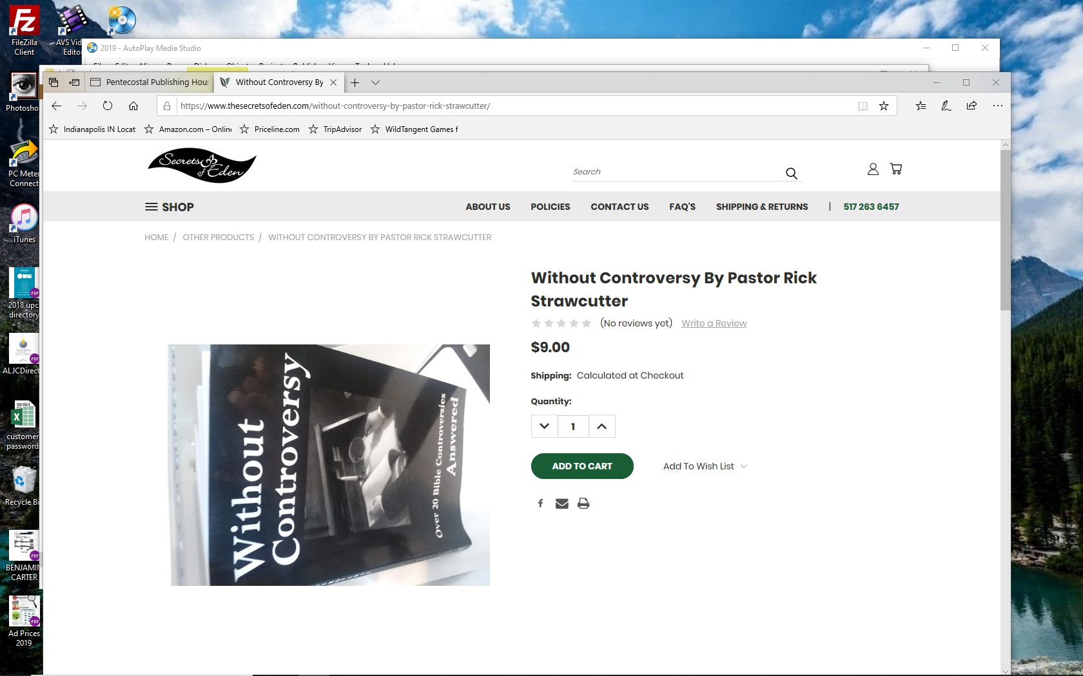

https://www.thesecretsofeden.com/without-controversy-by-pastor-rick-strawcutter/

Select link and paste into your search engine to purchase

